**Requirements For Running The Program**

# About Hardware:

* RAM 2 GB
* Free space 4GB on Disk which setup Software

# About Configuration:

* Require a OS Window 8 or later
* Require install [.NET FrameWork 4.7](https://dotnet.microsoft.com/download/dotnet-framework/net472) or later
* Install [DevExpress](https://www.devexpress.com/products/try/) (Optional) (**)
* Install [Bunifu FrameWork](https://bunifuframework.com/free-trial/) (Optional) (**)
* Install [Syncfuntion FrameWork](https://www.syncfusion.com/winforms-ui-controls/textbox) (Optional) (**)
* Install [Telerik GUI](https://www.telerik.com/products/winforms.aspx) (Optional) (**)
* Install [Git](https://git-scm.com/) (Compulsory) (**)

# To Run Demo:

This application is built on many Frameworks so it is almost difficult to use. To use it by skillfully, Please following document below:

* The First thing whenever you want to clone code on Github you need to install Git. **The tips for lazy and easily forget people that you use** [Github desktop](https://desktop.github.com/) **which provide by Git Inc to clone code and Use Extension** [Github for visual studio](https://visualstudio.github.com/) **to manage your source code by easy way**
* After complete step above you can clone and use code but everything you can receive from this code just a nearly thousand error notification to solve this problem isn’t easily because you are lacking of one of some of Library in (**) . So the basic solution and easiest is install all of that library and I know that every library in that list isn’t cheap maybe call that too expensive moreover it will take you a lot of time to learn , skill , research to get result that how to install it and if you believe that you are good and pro cracker so I will provide for you website which specializing in share app crack and you can try download it and try to crack .  
  To go this website please [following it](https://shareappscrack.com/)
* Comeback to main issues, how to run demo ok , I thinks I will lost a day to do it HAha.
* Firstly in Explorer of project have many folder  
    
  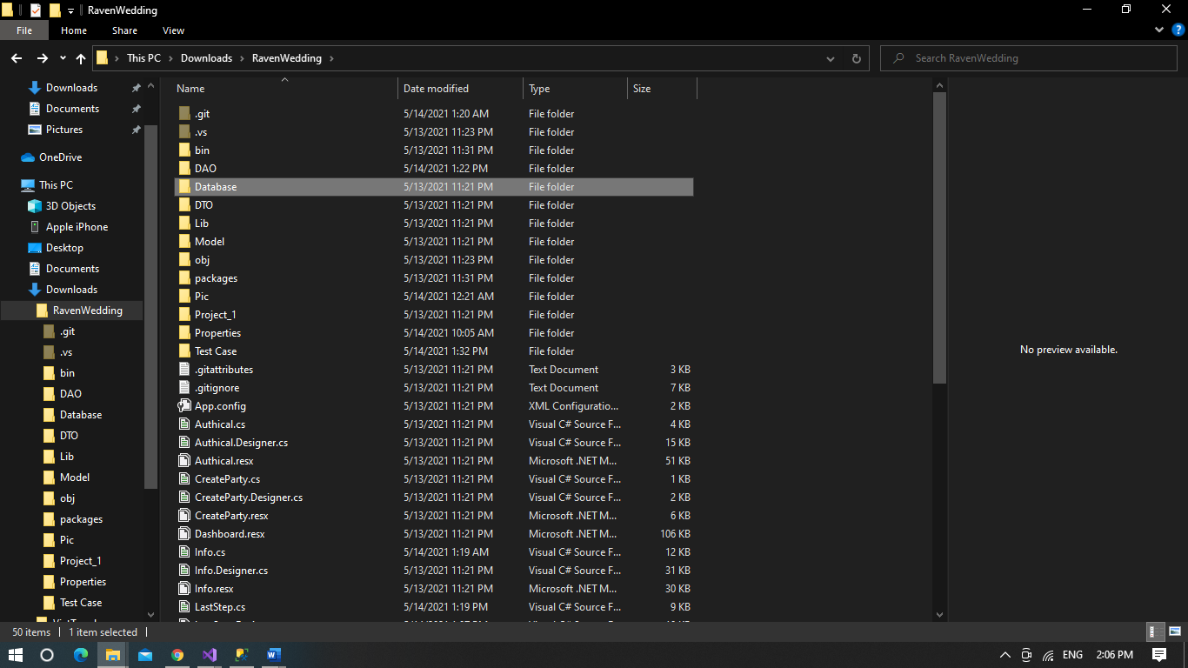

**Folder Database** contain file .sql and Data to try in database

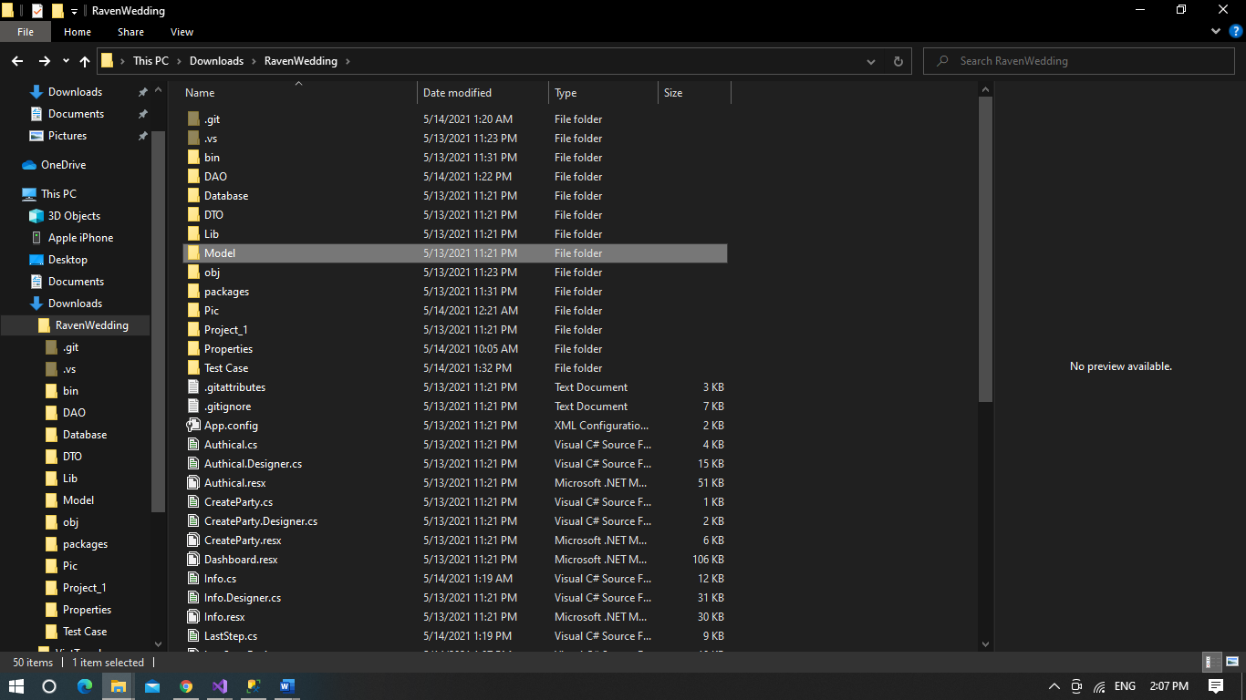

Folder Model, it have model to design database and all of programs

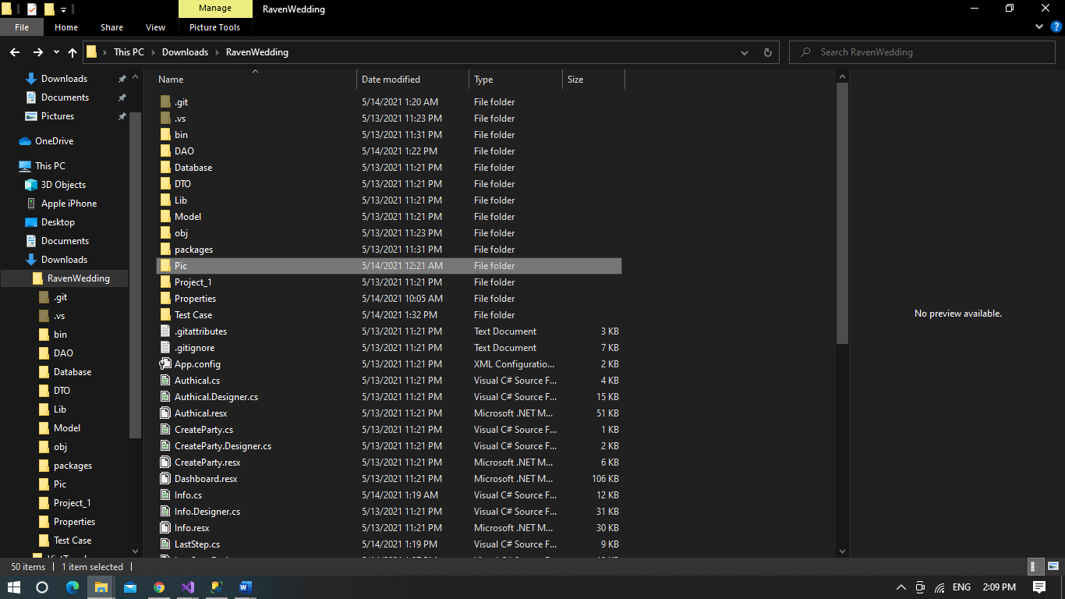

Folder pic have many icon to Design UI

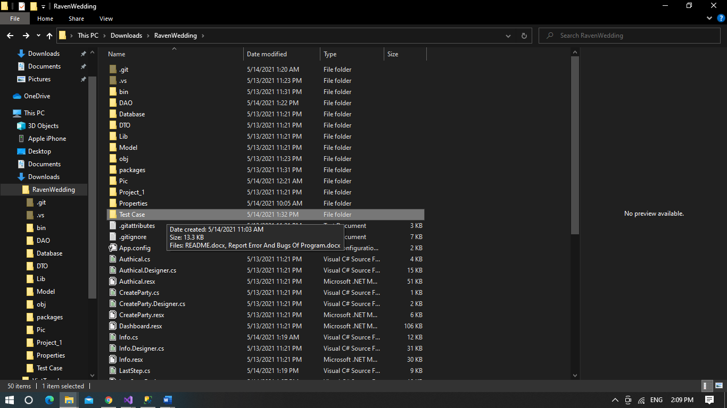

Folder Test Case Have Document to run App and Test case of it

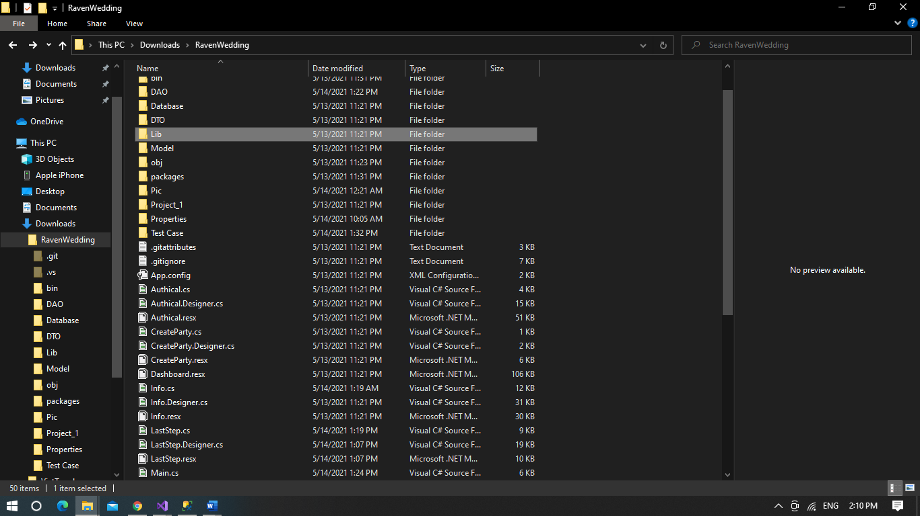

Folder Lib, it include all of compoment to design this is folder you need to care